Integer Programming Homework

Do problems in Section 9.3 # 4
Do problems in Section 9.5 # 2, 3
Model problem in Section 9.2 # 16, 21, 31, 35

9.3.4.
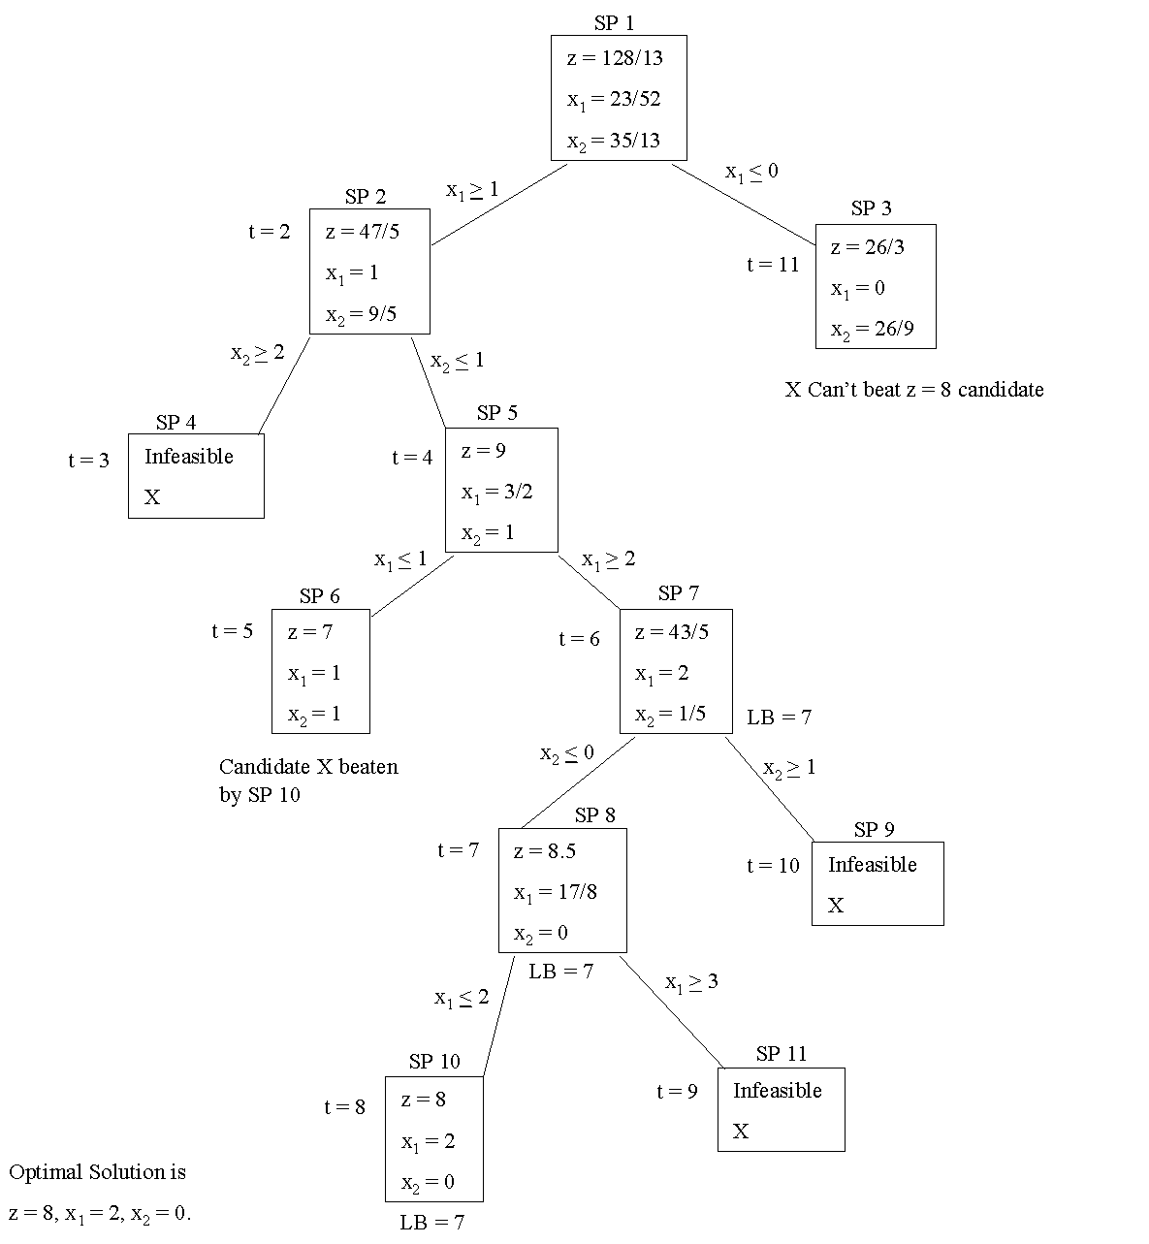

9.5 2
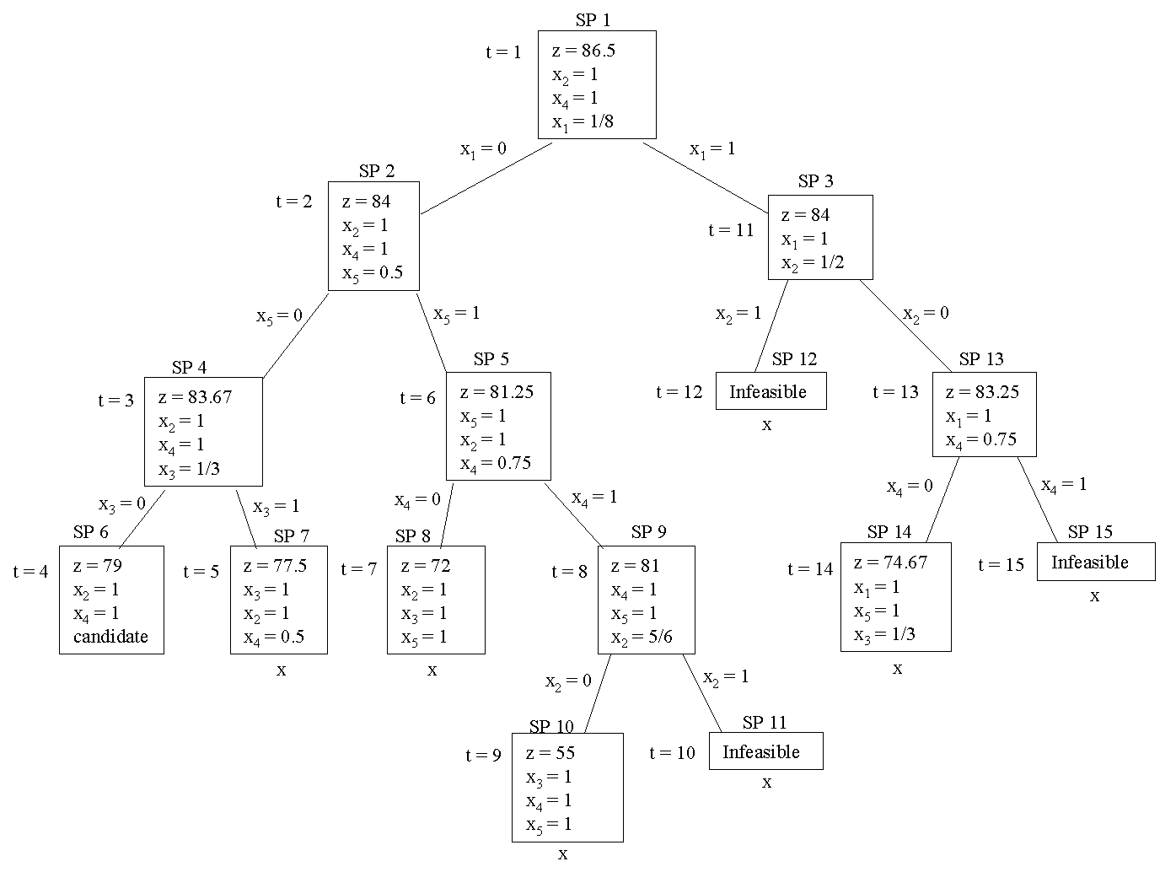

3. Letting x_{i} = 1 if item i is chosen and x_{i} = 0 otherwise
yields the following knapsack problem:

max z = 5x₁ + 8x₂ + 3x₃ + 7x₄
st 3x₁ + 5x₂ + 2x₃ + 4x₄≤6
x_{i} = 0 or 1
We obtain the following tree (for each subproblem any omitted variable equals 0):

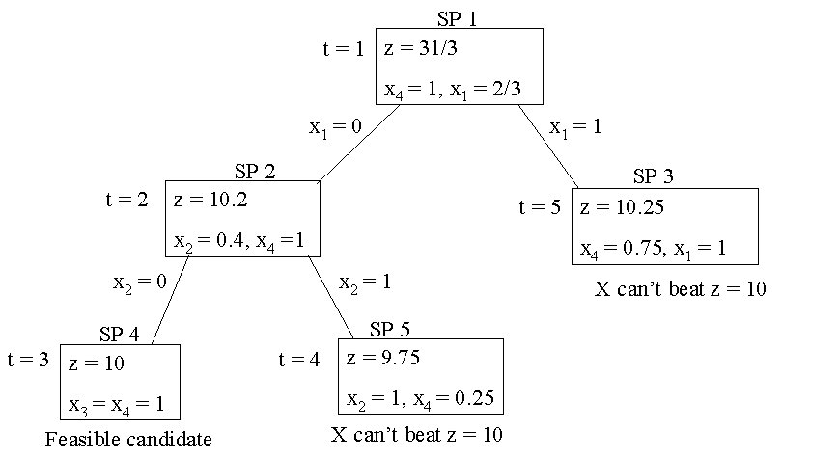

9.2.16

16. Let H = homes built and A = apartments built. Also let y₁ = 1 if marina is built, y₁ = 0 otherwise and y₂ = 1 if tennis court is built, y₂ = 0, otherwise. Then a correct IP formulation is

(objective function is in thousands of dollars of NPV)

max z = 48A + 46H - 40A - 40H - 1200y₁ - 2800y₂
st A + H≤10,000, y₁ + y₂ = 1
3A - H≤30,000y₃, y₁≤30,000(1 - y₃)
A, H non-negative integers and y_{i} = 0 or 1
We chose M = 30,000 because 3A - H ≤30,000 will always hold.

9.2.21

21. Let xij = number of air conditioners (in thousands) produced in city i for region j ( i = 1 is NY, j = 1 is East, etc.). Also let yj = 1 if factory is operated in city j, yj = 0 otherwise. Then the appropriate IP is(z is in thousands of dollars)
min z = 6000y1 + 5500y2 + 5800y3 +6200y4 + 206x11 + 225x12 + 230x13 +290x14 + 225x21 + 206x22 + 221x23 + 270x24 + 230x31 + 221x32 + 208x33 + 262x34 + 290x41 + 270x42 + 262x43 + 215x44
st x11 + x21 + x31 + x41≥100 (East)
x12 + x22 + x32 + x42≥150 (South)
x13 + x23 + x33 + x43≥110 (Midwest)
x14 + x24 + x34 + x44≥90 (West)
x11 + x12 + x13 + x14≤150y1 (NY)
x21 + x22 + x23 + x24≤150y2 (Atl)
x31 + x32 + x33 + x34≤150y3 (Chic)
x41 + x42 + x43 + x44≤150y4 (LA)
(Either x13≥50 or x23≥50)
50 - x13≤50y
50 - x23≤50(1 - y)
All xij integer; y, all yi = 0 or 1

9.2.31

31. Let xic = 1 if product i is assigned to compartment c, xic = 0 otherwise. ei = shortage of product i (1 = super 2 = regular, 3 = unleaded), gic = gallons of product i in compartment c.
min z = 10e1 + 8e2 + 6e3
st g11 + g21 + g31≤2700
g12 + g22 + g32≤2800
g13 + g23 + g33≤1100
g14 + g24 + g34≤1800
g15 + g25 + g35≤3400
g11 + g12 + g13 + g14 + g15 + e1 - f1 = 2900
g21 + g22 + g23 + g24 + g25 + e2 - f2 = 4000
g31 + g32 + g33 + g34 + g35 + e3 - f3 = 4900
gi1≤2700xi1, gi2≤2800xi2, gi3≤1100xi3, gi4≤1800xi4
gi5≤3400xi5 ( i = 1,2,3)
x1j + x2j + x3j≤1 (j = 1, 2, 3, 4, 5)
All xij = 0 or 1 All other variables ≥0
e1≤500,e2≤500,e3≤500

9.2.35

38. Let Xij = 1 if size i box is used to meet demand for type i,i+1,...j boxes. Let Yi = 1 if type i box is used at all and Yi = 0 if type i box is not used. Answer is on LINDO printout

Section 9.2 Problem 38 Printout

MIN 13200 X11 + 9900 X12 + 16500 X13 + 23100 X14 + 6600 X15
+ 13200 X16 + 6600 X17 + 9000 X22 + 15000 X23 + 21000 X24 + 6000 X25
+ 12000 X26 + 6000 X27 + 13000 X33 + 18200 X34 + 5200 X35 + 10400 X36
+ 5200 X37 + 16800 X44 + 4800 X45 + 9600 X46 + 4800 X47 + 3800 X55
+ 7600 X56 + 3800 X57 + 7200 X66 + 3600 X67 + 3400 X77 + 1000 Y1
+ 1000 Y2 + 1000 Y3 + 1000 Y4 + 1000 Y5 + 1000 Y6 + 1000 Y7
SUBJECT TO
2) X11 = 1
3) X12 + X22 = 1
4) X13 + X23 + X33 = 1
5) X14 + X24 + X34 + X44 = 1
6) X15 + X25 + X35 + X45 + X55 = 1
7) X16 + X26 + X36 + X46 + X56 + X66 = 1
8) X17 + X27 + X37 + X47 + X57 + X67 + X77 = 1
9) X11 - Y1 <= 0
10) X12 - Y1 <= 0
11) X13 - Y1 <= 0
12) X14 - Y1 <= 0
13) X15 - Y1 <= 0
14) X16 - Y1 <= 0
15) X17 - Y1 <= 0
16) X22 - Y2 <= 0
17) X23 - Y2 <= 0
18) X24 - Y2 <= 0
19) X25 - Y2 <= 0
20) X26 - Y2 <= 0
21) X27 - Y2 <= 0
22) X33 - Y3 <= 0
23) X34 - Y3 <= 0
24) X35 - Y3 <= 0
25) X36 - Y3 <= 0
26) X37 - Y3 <= 0
27) X44 - Y4 <= 0
28) X45 - Y4 <= 0
29) X46 - Y4 <= 0
30) X47 - Y4 <= 0
31) X55 - Y5 <= 0
32) X56 - Y5 <= 0
33) X57 - Y5 <= 0
34) X66 - Y6 <= 0
35) X67 - Y6 <= 0
36) X77 - Y7 <= 0
END

